Compiler Lab

File

Submitted by- Shreyansh Jain

11css-59

INDEX

1.DFA

2.Mealy machine

3.Moore machine

4.Regular Expression

DFA

#include<stdio.h>

#include<conio.h>

void main()

{

FILE \*p;

int s[10],a[10][10],fin,start,i=0,j=0,m,n,size;

char c=' ',str[50],ch;

clrscr();

p=fopen("file.txt","r");

fscanf(p,"%d\n",&start);

while(c!='\n')

{

fscanf(p,"%d%c",&s[i],&c);

i++;

}

size=i;

i=0;

while(!feof(p))

{

fscanf(p,"%d%c",&a[i][j],&c);

if(c=='\n')

{

i++;

j=0;

}

else

{

j++;

n=j;

}

}

m=(i-1);

printf("\nDFA:\n");

for(i=0;i<m;i++)

{

for(j=0;j<=n;j++)

{

printf("%d\t",a[i][j]);

}

printf("\n");

}

do

{

fflush(stdin);

printf("\nEnter the string:\n");

gets(str);

fin=start;

i=0;

while(fin!=-1&&str[i]!='\0')

{

fin=a[fin][str[i]-97];

i++;

}

if(str[i]!='\0')

{

printf("\nString not accepted\n");

}

else if(fin==-1)

{

printf("\nString not accepted\n");

}

else

{

for(i=0;i<size;i++)

{

if(fin==s[i])

{

printf("\nString accepted\n");

break;

}

}

}

printf("\nDo you want to enter more strings?(y/n)\n");

scanf("%c",&ch);

}while(ch=='y');

getch();

}

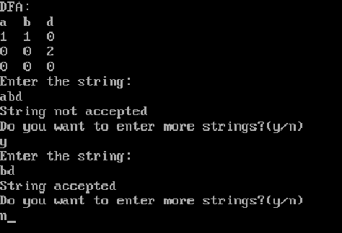

Mealy Machine

#include<stdio.h>

#include<conio.h>

int main()

{

FILE \*p;

int fa[10][10],cs,init,i=0,j=0,m,n,size,op[50],k=0;

char c=' ',str[100],ch;

p=fopen("file.txt","r");

fscanf(p,"%d\n",&init);

while(!feof(p))

{

fscanf(p,"%d%c",&fa[i][j],&c);

if(c=='\n')

{

i++;

j=0;

}

else

{

j++;

n=j;

}

}

m=(i-1);

printf("\nMealy machine(Input followed by its output)\n");

for(i=0;i<m;i++)

{

for(j=0;j<=n;j++)

{

printf("%d\t",fa[i][j]);

}

printf("\n");

}

do

{

fflush(stdin);

printf("\nEnter the string:\n");

gets(str);

cs=init;

i=0,k=0;

while(cs!=-1&&str[i]!='\0')

{

if(((str[i]-48)\*2)>n)

cs=-1;

else

{

cs=fa[cs][(str[i]-48)\*2];

op[k]=fa[cs][((str[i]-48)\*2)+1];

i++;

k++;

}

}

if(str[i]=='\0')

{

printf("\nThe output of mealy machine is:\n");

for(i=0;i<k;i++)

printf("%d",op[i]);

}

else if(cs==-1)

{

printf("\nString not accepted\n");

}

printf("\nDo you want to enter more strings?(y/n)\n");

scanf("%c",&ch);

}while(ch=='y');

getch();

}

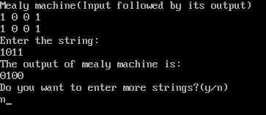

Moore Machine

#include<stdio.h>

#include<conio.h>

int main()

{

FILE \*p;

int fa[10][10],cs,init,i=0,j=0,m,n,size,op[50],k=0;

char c=' ',str[100],ch;

p=fopen("file.txt","r");

fscanf(p,"%d\n",&init);

while(!feof(p))

{

fscanf(p,"%d%c",&fa[i][j],&c);

if(c=='\n')

{

i++;

j=0;

}

else

{

j++;

n=j;

}

}

m=(i-1);

printf("\nMoore machine:(output followed by transitions)\n");

for(i=0;i<m;i++)

{

for(j=0;j<=n;j++)

{

printf("%d\t",fa[i][j]);

}

printf("\n");

}

do

{

fflush(stdin);

printf("\nEnter the string:\n");

gets(str);

cs=init;

i=0,k=0;

while(cs!=-1&&str[i]!='\0')

{

if(cs>=n)

cs=-1;

else

{

op[k]=fa[cs][n];

cs=fa[cs][(str[i]-48)];

i++;

k++;

}

}

if(str[i]=='\0')

{

printf("\nOutput produced by moore machine is:\n");

for(i=0;i<k;i++)

printf("%d",op[i]);

}

else if(cs==-1)

{

printf("\nString not accepted\n");

}

printf("\nDo u want to enter more strings?(y/n)\n");

scanf("%c",&ch);

}while(ch=='y');

getch();

}

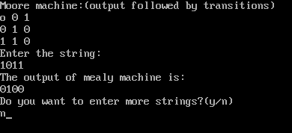

Regular Expression

#include<stdio.h>

#include<conio.h>

char string[40],regex[20];

int si,ri,bracket;

int checksymbol(int i)

{ if(regex[i]=='(')

{ bracket++;

return 0;

}

else if(regex[i]==')')

{ bracket--;

return 0;

}

else if(regex[i]=='+')

{ while(regex[ri]!=')')

{ ri++;

}

return 0;

}

else if(regex[i]=='\*')

{

return 0;

}

else

{ return 1;

}

}

void main()

{ char ch;

int sym;

clrscr();

si=0; ri=0;

bracket=0;

printf("Enter the Regular Expression:\t");

gets(regex);

printf("Enter the String:\t");

gets(string);

while(1)

{ sym=checksymbol(ri);

if(sym==1)

{ if(string[si]==regex[ri])

{ while(string[si]==regex[ri])

{ si++;

ri++;

if(string[si]=='\0'&& regex[ri]=='\0')

{ printf("String acceped!!");

getch();

exit();

}

}

}

else

{ ri++;

}

}

else

{ ri++;

}

}

getch();

}

